**EXPERIMENT – 1**

|  |  |
| --- | --- |
| **Student Name**: SANSKAR AGRAWAL | **UID:** 20BCS5914 |
| **Branch**: CSE | **Section/Group:** 806/B |
| **Semester**: 5th | **Date of Performance**: 28/08/2022 |
| **Subject Name**: MULTIMEDIA Lab | **Subject Code:** 20CSP-339 |

**AIM:** - Design a Visiting Card containing at least one graphics and text information using photopea.

**Hardware Requirements: -** Minimum 384MB RAM, 100 GB hard Disk, processor with 2.1 MHz

**Software Requirements: -**, Photopea

**Tools Used: -** Type Tool, Magic Wand, Lasso select

**Study:**

**Step 1 :-** Create the new project and set the dimensions according to the requirement.

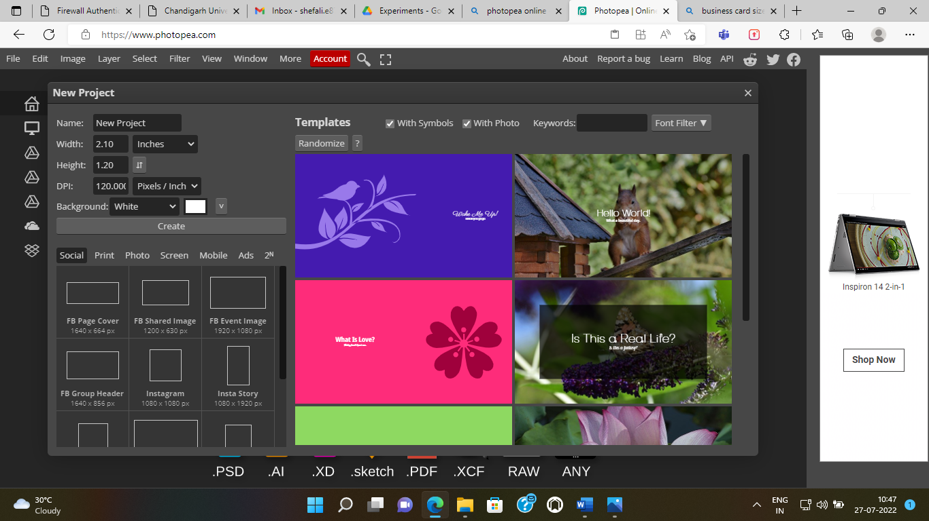



As you can see on the above image, we set the dimensions according to the default size of the Visiting Card.

**Step 2: -** Now to select the background image for the visiting card. You can take images through various methods.

1. If the image is in your system, then take it from FILE ---> Open and place.

2. You can copy the image from online websites like “pixaby” and paste it on the template.

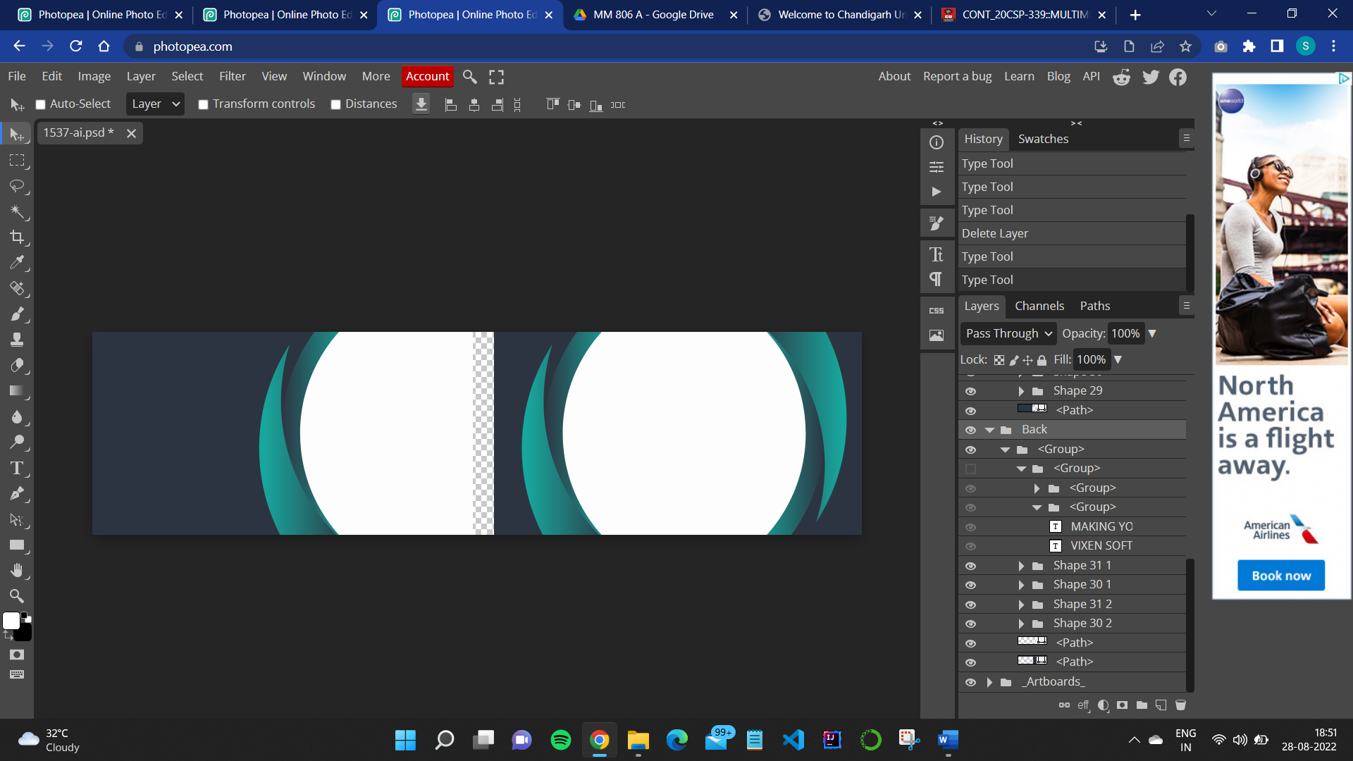

**Step 3: -** After that we need to write down the details of the person or company according to the format of visiting card for that we will use **TYPE TOOL.**

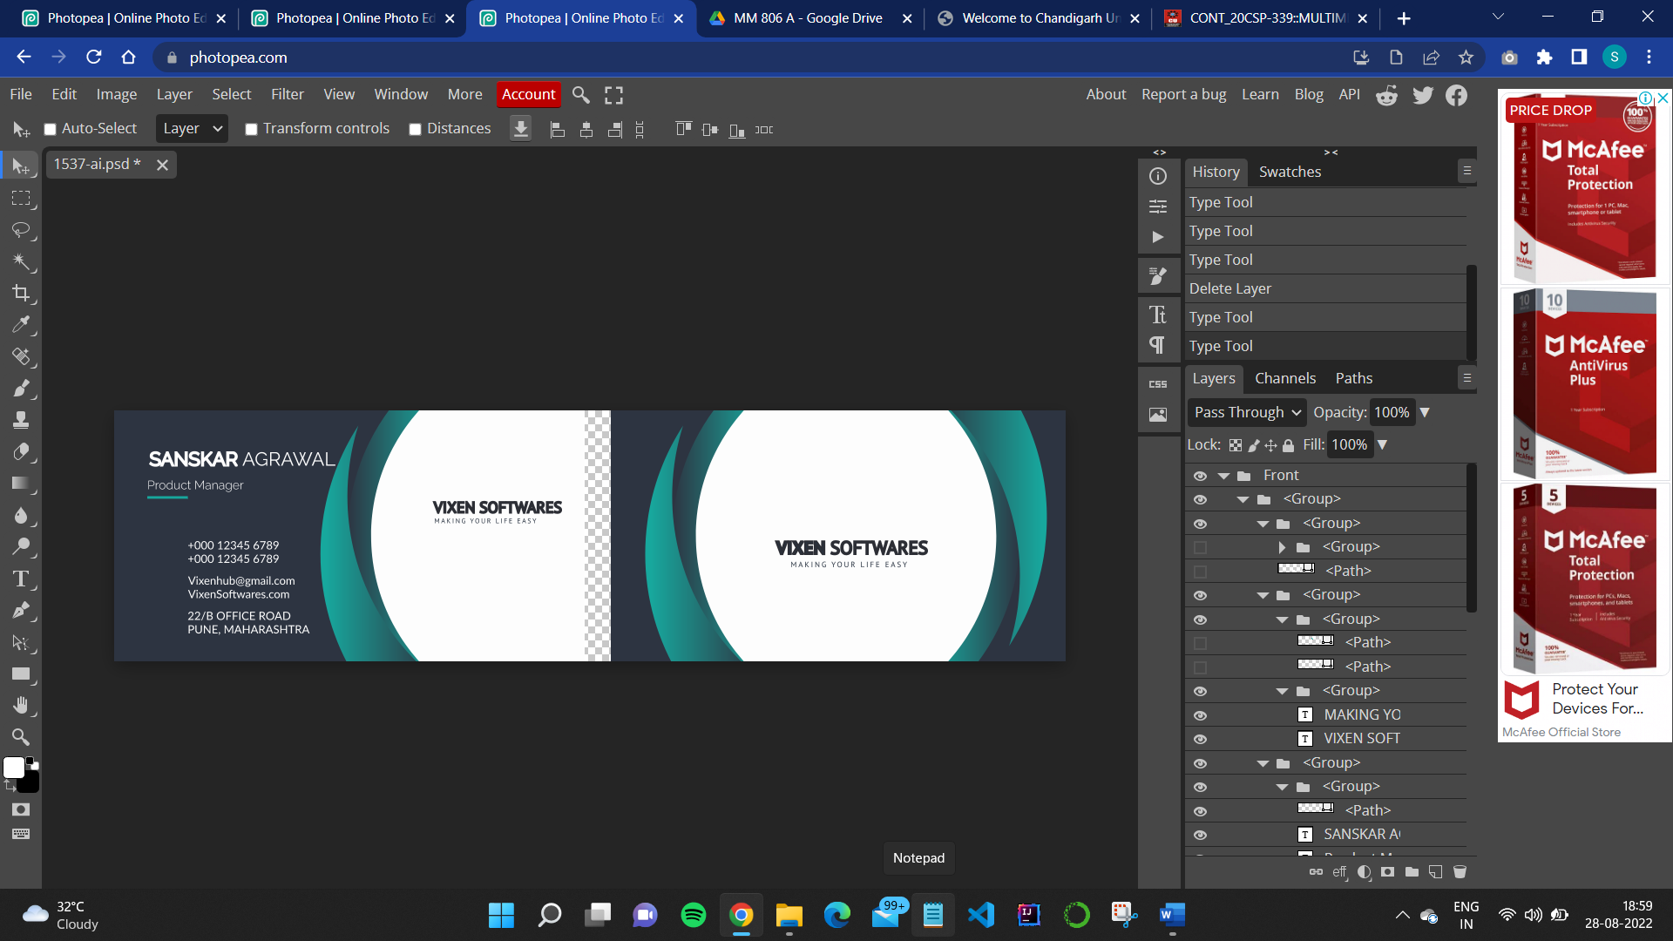

once you select the type tool the text layer will be added on the above of all the layers.

**Step 4: -** Now add the image or logo of the organization. For adding the image follow step-2.

**OUTPUT :-**

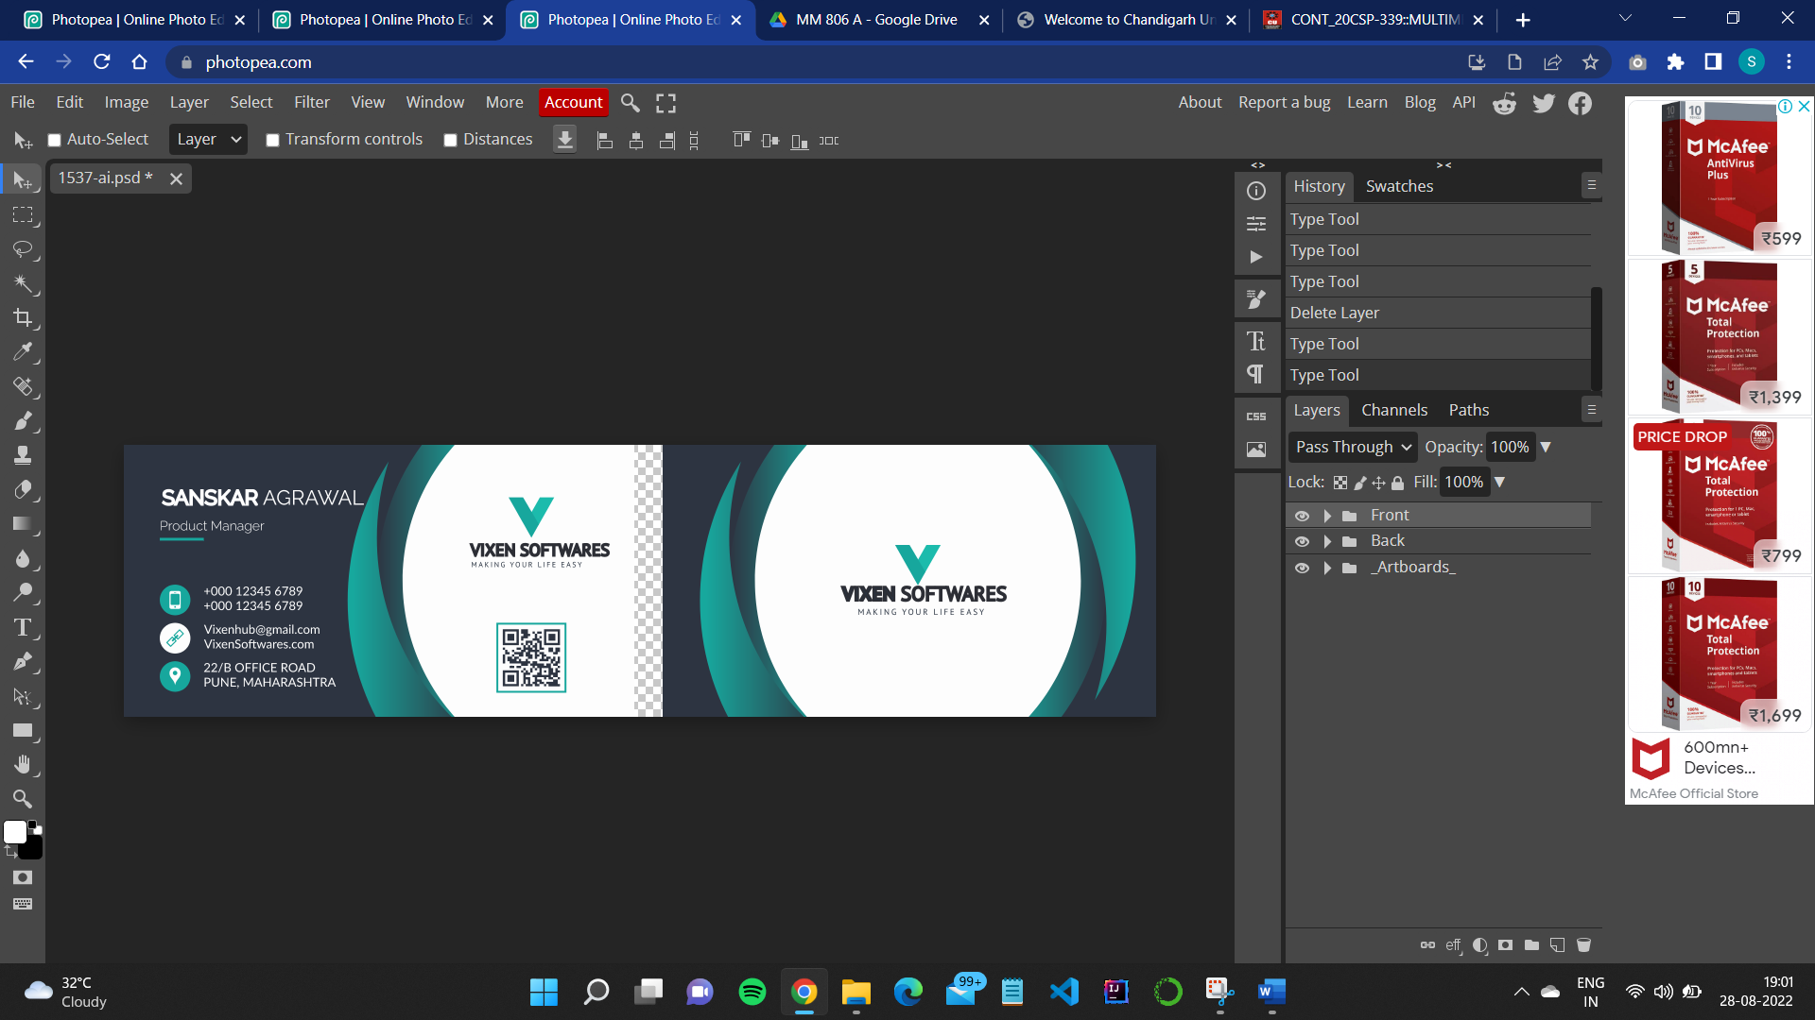

**Learning Outcomes(What I have learnt):-**

1. To create visiting card using photopea.
2. To understand and use different photopea tools.

**Evaluation Grid (To be created as per the SOP and Assessment guidelines by the faculty):**

|  |  |  |  |
| --- | --- | --- | --- |
| Sr. No. | Parameters | Marks Obtained | Maximum Marks |
| 1. |  |  |  |
| 2. |  |  |  |
| 3. |  |  |  |
|  |  |  |  |